**Quick guide for creating a Domino application from GitHub**

<http://www.notessidan.se/blogg.nsf/xstart.xsp?post=C5E1282A37AC31EFC1257DCA00353318>

More and more Domino developers add their open source projects to [GitHub](https://github.com/) This means that Domino databases (NSF) is stored as text on Github allowing anyone to browse the code.  
  
This guide show you how to download an NSF project stored on Github, import it into Domino Designer and create an NSF from the text files.  
  
If you need to setup source control from DDE to Github, instead [use this guide](http://www.notessidan.se/blogg.nsf/xstart.xsp?post=5E6F2BB878958180C1257DCB005FEEFE)  
  
  
**Step 1**  
Find a Github "nsf" project and download the zip file

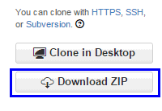  
  
**Step 2**,  
Extract to disk only the ODP folder from the zip file  
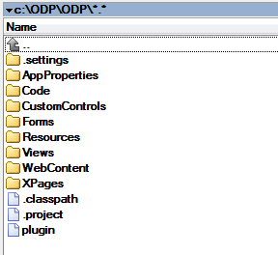  
  
  
**Step 3.**  
Go to the package explorer view in DDE and Right click and choose import  
  
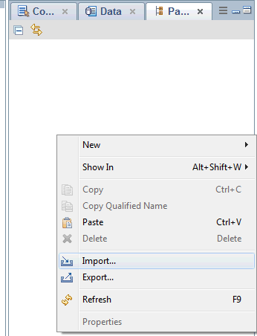  
  
**Step 4**  
Select to Import "Existing Projects into workspace  
  
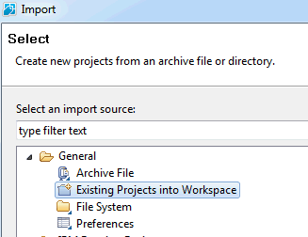  
  
  
**Step 5**  
Browse to the ODP Folder on your disk  
  
  
  
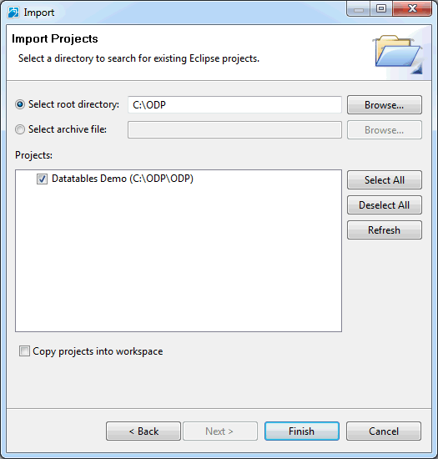  
  
**Step 6**  
Your project is now in the package explorer but it is still not added to NSF  
  
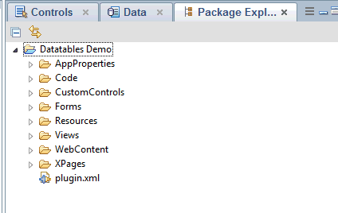  
  
  
**Step 7**  
Right click the project in package explorer and choose Team Development\Asssociate with new NSF  
  
  
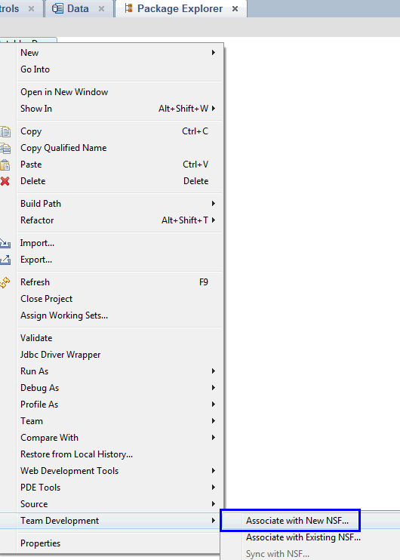  
  
  
  
**Step 8**  
Tell the dialog which filename you want for the new nsf  
  
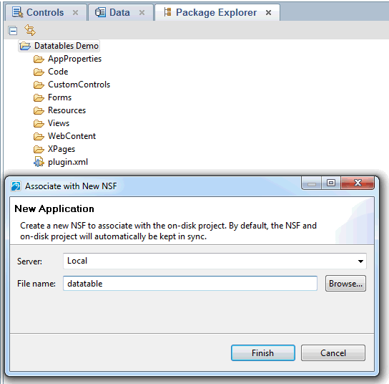  
  
  
**Step 9**  
Wait a few moments for the import to finish  
  
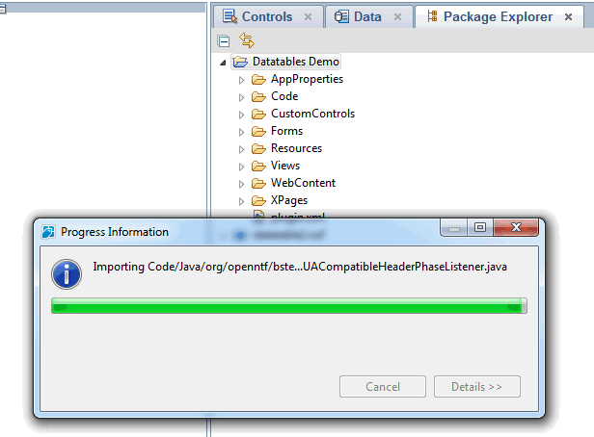  
  
  
**Step 10**  
Your NSF is now in the applications view in DDE  
  
  
